
Shoulder Flexibility
Stretches


Submitted by: Healthcare Therapy Services, Inc.
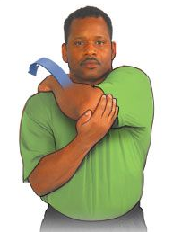

Shoulder Stretch
- Bring your left hand up onto your right shoulder
and support your elbow with your right hand.
- Gently pull left elbow toward right shoulder.
When a stretch is felt, hold for 10 to 15 seconds.
- Repeat with the other side. Alternating sides 5 times.

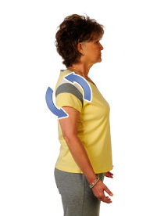
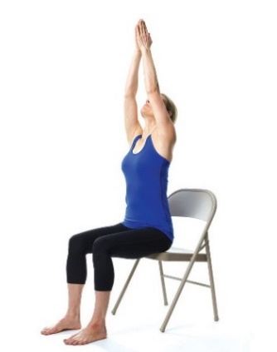
Shoulder Rolls
- While standing or sitting let your arms hang down to the side.
- Breathe in and lift the shoulder up toward the ears.
- Move your shoulders back, squeezing shoulder blades together.
- Exhale and drop the shoulder back.
- Relax and repeat 10 times.

Shoulder & Upper Back Stretch
- Bring palms together in front of chest
and take a breath in through your nose.
- Exhale as you bring your arms up.
Straighten arms overhead with palms forward.
- Lower your arms out to the side and back to starting position. Repeat 10 times per day.

[insert your contact information, etc.]
[insert your logo]

