
Seated Leg Strengthening Exercises
Submitted by: Healthcare Therapy Services, Inc. Inc.

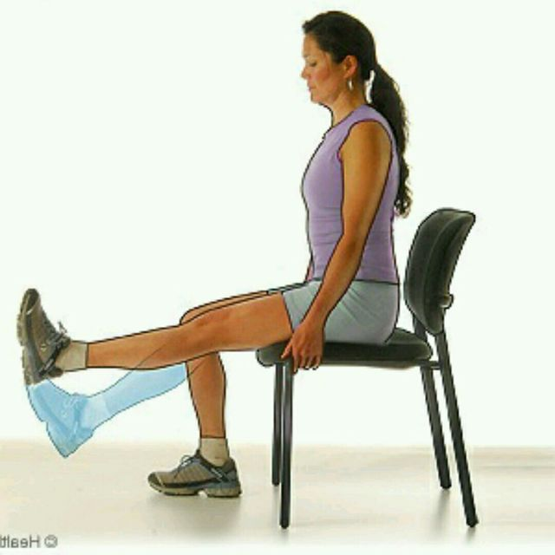
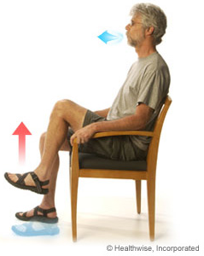
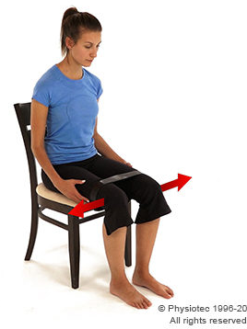


Side Hip Raise

Sit up straight in a chair with your feet flat on the floor. Inhale as you slowly lift your left leg up and to the side. Try to keep your foot in a right angle and toes pointed forward. Exhale as you slowly return your leg to the ground. Repeat 10 times. Do the same for opposite leg.

*Extra Challenge - Place a resistance band around thighs

Knee Extension
Sit up straight in a chair with your feet flat on the floor. Inhale as you lift and slowly straighten your left knee in front of you. Tilt your toes towards you as best you can. Hold for a few seconds. Exhale as you slowly return your left foot to the ground. Repeat 10 times. Do the same with your right knee.
*Extra Challenge - Try adding ankle weights

Seated March
Sit up straight in a chair with your feet flat on the floor. Inhale as you slowly lift your left knee into the air as high as you can. Exhale as you slowly lower it back down to the ground. Repeat 10 times total. Do the same with your right knee.
*Extra Challenge - Try adding ankle weights

