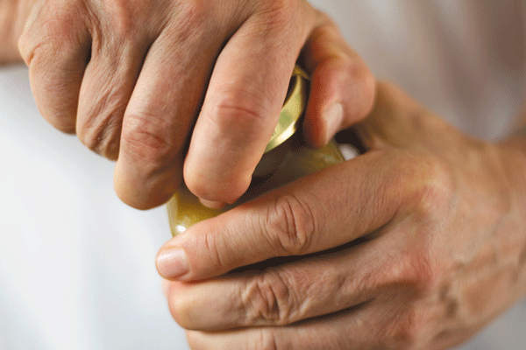
Improve Your
Grip Strength


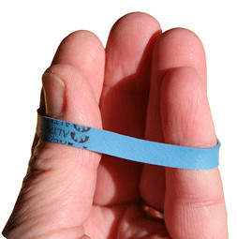
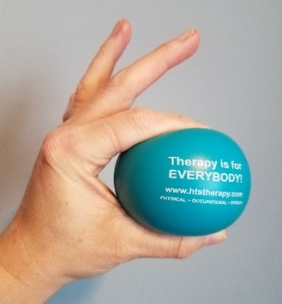
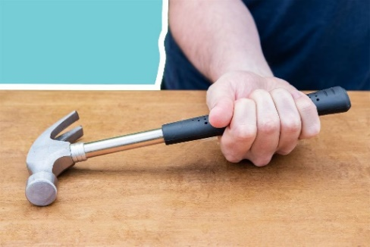
[insert your logo]
[insert your contact information, etc.]
Submitted by: Healthcare Therapy Services, Inc. Inc.

Rubber Band Finger Extension
Place any size rubber band around the tips of your fingers. Slowly extend your fingers against the force of the rubber band. Hold the extended position for
3 seconds and then slowly release back to the starting position. Repeat 10 to 15 times.

Stress Ball Squeeze
Squish a stress ball or tennis ball with your entire
hand for 5 to 10 pulses. Repeat using just thumb
and pointer finger. Progress through each finger.
Switch hands and repeat sequence.

Hammer Strengthening Forearm Exercise
Hold the end of a hammer or water bottle in one hand with your forearm resting on a table. Slowly turn the hammer over so your palm is down. Hold for 3 seconds. Then, slowly turn the hammer over so your palm faces up. Hold for 3 seconds. Repeat 15 times.

